UNITED STATES
SECURITIES AND EXCHANGE COMMISSION
Washington, D.C. 20549

SCHEDULE 14A

Proxy Statement Pursuant to Section 14(a) of
the Securities Exchange Act of 1934 (Amendment No. )

Filed by the Registrant ☒
Filed by a Party other than the Registrant ☐
Check the appropriate box:
☐ | Preliminary Proxy Statement
☐ | Confidential, for Use of the Commission Only (as permitted by Rule 14a-6(e)(2))
☐ | Definitive Proxy Statement
☒ | Definitive Additional Materials
☐ | Soliciting Material under §240.14a-12

CYPHERPUNK TECHNOLOGIES INC.
(Name of Registrant as Specified In Its Charter)

(Name of Person(s) Filing Proxy Statement, if other than the Registrant)

Payment of Filing Fee (Check all boxes that apply):
☒ | No fee required.
☐ | Fee paid previously with preliminary materials.
☐ | Fee computed on table in exhibit required by Item 25(b) per Exchange Act Rules 14a-6(i)(1) and 0-11.

 | 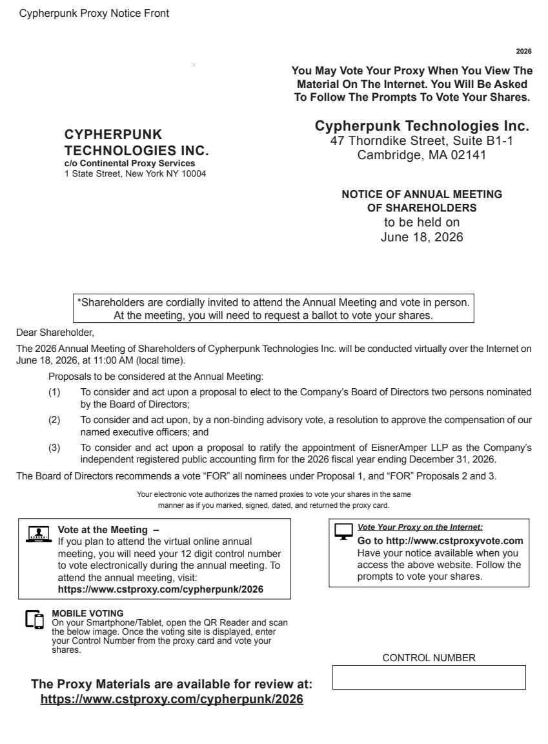 | 2026 You May Vote Your Proxy When You View The Material On The Internet. You Will Be Asked To Follow The Prompts To Vote Your Shares. Cypherpunk Technologies Inc. 47 Thorndike Street, Suite B1-1 Cambridge, MA 02141 NOTICE OF ANNUAL MEETING OF SHAREHOLDERS to be held on June 18, 2026 *Shareholders are cordially invited to attend the Annual Meeting and vote in person. At the meeting, you will need to request a ballot to vote your shares. Dear Shareholder, The 2026 Annual Meeting of Shareholders of Cypherpunk Technologies Inc. will be conducted virtually over the Internet on June 18, 2026, at 11:00 AM (local time). Proposals to be considered at the Annual Meeting: (1) To consider and act upon a proposal to elect to the Company’s Board of Directors two persons nominated by the Board of Directors; (2) To consider and act upon, by a non-binding advisory vote, a resolution to approve the compensation of our named executive officers; and (3) To consider and act upon a proposal to ratify the appointment of EisnerAmper LLP as the Company’s independent registered public accounting firm for the 2026 fiscal year ending December 31, 2026. The Board of Directors recommends a vote “FOR” all nominees under Proposal 1, and “FOR” Proposals 2 and 3. Your electronic vote authorizes the named proxies to vote your shares in the same manner as if you marked, signed, dated, and returned the proxy card. Vote Your Proxy on the Internet: Go to http://www.cstproxyvote.com Have your notice available when you access the above website. Follow the prompts to vote your shares. The Proxy Materials are available for review at: https://www.cstproxy.com/cypherpunk/2026 CONTROL NUMBER CYPHERPUNK TECHNOLOGIES INC. c/o Continental Proxy Services 1 State Street, New York NY 10004 Cypherpunk Proxy Notice Front Vote at the Meeting – If you plan to attend the virtual online annual meeting, you will need your 12 digit control number to vote electronically during the annual meeting. To attend the annual meeting, visit: https://www.cstproxy.com/cypherpunk/2026 MOBILE VOTING On your Smartphone/Tablet, open the QR Reader and scan the below image. Once the voting site is displayed, enter your Control Number from the proxy card and vote your shares.
 | 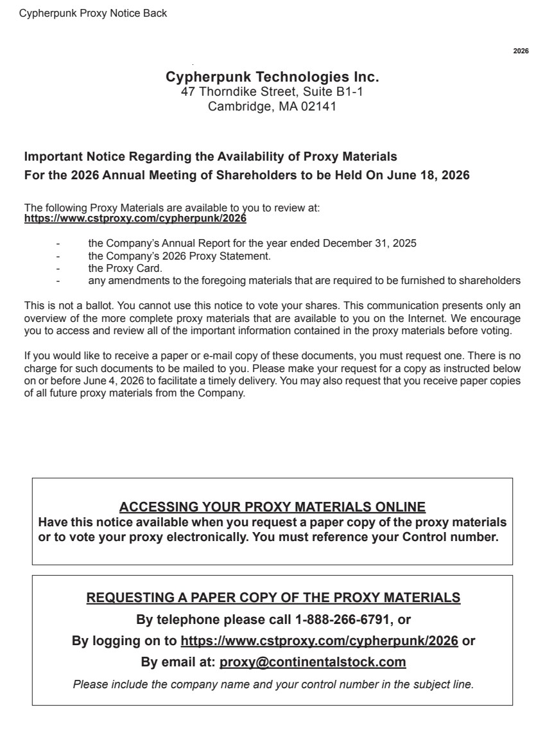 | 2026 Cypherpunk Technologies Inc. 47 Thorndike Street, Suite B1-1 Cambridge, MA 02141 Important Notice Regarding the Availability of Proxy Materials For the 2026 Annual Meeting of Shareholders to be Held On June 18, 2026 The following Proxy Materials are available to you to review at: https://www.cstproxy.com/cypherpunk/2026 - the Company’s Annual Report for the year ended December 31, 2025 - the Company’s 2026 Proxy Statement. - the Proxy Card. - any amendments to the foregoing materials that are required to be furnished to shareholders This is not a ballot. You cannot use this notice to vote your shares. This communication presents only an overview of the more complete proxy materials that are available to you on the Internet. We encourage you to access and review all of the important information contained in the proxy materials before voting. If you would like to receive a paper or e-mail copy of these documents, you must request one. There is no charge for such documents to be mailed to you. Please make your request for a copy as instructed below on or before June 4, 2026 to facilitate a timely delivery. You may also request that you receive paper copies of all future proxy materials from the Company. ACCESSING YOUR PROXY MATERIALS ONLINE Have this notice available when you request a paper copy of the proxy materials or to vote your proxy electronically. You must reference your Control number. REQUESTING A PAPER COPY OF THE PROXY MATERIALS By telephone please call 1-888-266-6791, or By logging on to https://www.cstproxy.com/cypherpunk/2026 or By email at: proxy@continentalstock.com Please include the company name and your control number in the subject line. Cypherpunk Proxy Notice Back

